# **CP1N1-24721015 李鹏麒**

# **所属内容：Experimental N1-C1-20240918**

# **完成部分说明：编写算法与代码、调试与测试、撰写实验报告**

**The programme language**: C language

**The programming platform**: Visual Studio 2022

**Program function**:

1.Display “the first programming experience by class 1” on the screen.

2.Calculate a student’s course grade,where each individual grade is a floating-point number.

**Program algorithm**:

Score=Experiment score(<=50)+Experience document score(<=10)+Test score(<=40) + Bonus score(<=5).

If the total score is more than 100,it will be recorded as 100,and output the values of all the variables.

**Program flow chart:**

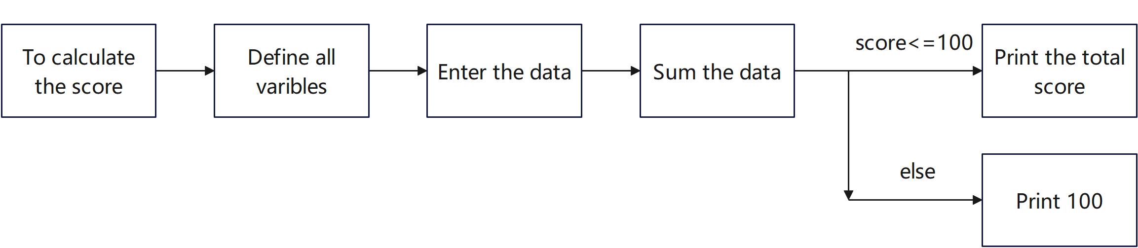

**Program experiment test:**

After the program runs, the statement in the function 1 can be displayed normally. After entering the student score, the program can correctly calculate the score, and the simplicity of the code can still be optimized.